FUNCTIONAL SPECIFICATION DOCUMENT (FSD)
CUSTOMER CARE REGISTRY SYSTEM

Date | 18 July 2026
Team ID | SB-IBM-2026-07-0012
Project Name | Customer Care Registry System
Maximum Marks | 4 Marks

1. Introduction
System Name: Project Title: Customer Care Registry System (CCRS)
Project Team Members & Roles:
• Priyanka Degala - Team Lead (PD) - Frontend Developer
• Chandrakala Marri - Member (CM) - Backend Design & QA Testing
• Eswarasai Marre - Member (EM) - Backend Developer
• Triloka Pavani Mandhapati - Member (TPM) - Database Developer
• Santhosh Nikhil Moka - Member (SNM) - Fullstack Feature Developer
This Functional Specification Document (FSD) provides a technical and functional footprint of the Customer Care Registry System. It defines the software's components, operational architecture, API contract definitions, setup mechanisms, authentication schemes, testing paradigms, and user interface workflows. The CCRS provides a role-based environment for Customers, Agents, and Administrators, ensuring secure, transparent complaint registration and resolution.
2. Project Overview
The CCRS is designed to modernize utility customer care. By replacing spreadsheets and emails, the system helps organizations organize incoming customer issues, assign them to verified agents based on departments, track ticket progression in real-time, and log performance feedback. Key features include role-based dashboards, JWT-secured authentication, dynamic custom registration fields, in-app ticket messaging, and administrative analytics charts.
3. Architecture
The system follows a standard three-tier pattern: Presentation Layer (Vite React Client), Logic Layer (Express/Node Server), and Data Layer (MongoDB Atlas NoSQL Store). Interaction is stateless, using JSON Web Tokens (JWT) for authentication.
- Vite React Client: Serves the Single Page Application (SPA), managing rendering and local application states.
- Express Server: Serves as the API Gateway, handling routing, validations, and database updates.
- MongoDB Atlas: Stores documents in collections (Customers, Agents, Admins, Complaints, Feedback, Notifications, CustomFields).
- 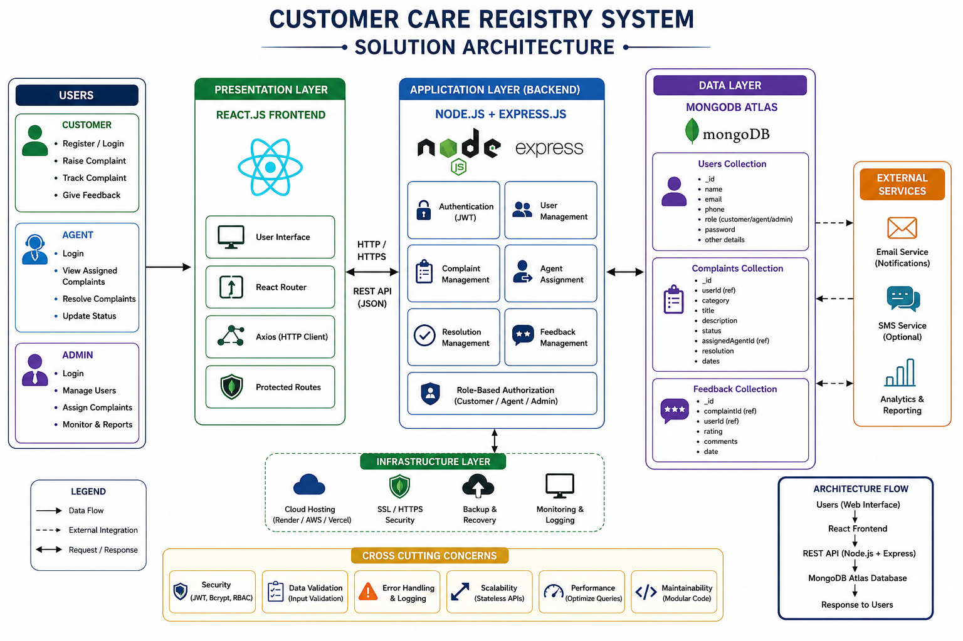

4. Setup Instructions
Prerequisites: Node.js (v18+), npm (v9+), and a MongoDB Atlas Cluster connection URI.
Installation Steps:
1. Clone the project repository and open it in a shell.
2. Navigate to the server directory and install backend dependencies: 'cd server && npm install'
3. Create a '.env' file inside the server directory with variables: PORT=5001, MONGO_URI=your_mongodb_uri, JWT_SECRET=your_secret_key
4. Navigate to the client directory and install frontend dependencies: 'cd ../client && npm install'
5. Create a '.env' file in client with: VITE_API_URL=http://localhost:5001/api
5. Folder Structure
customer-registry/
├── client/
│ ├── public/
│ ├── src/
│ │ ├── components/ # Common UI elements (Navbar, Button, Card)
│ │ ├── context/ # AuthContext state management
│ │ ├── layouts/ # Layout grids for Admin, Agent, and Customer
│ │ ├── pages/ # Pages (Login, Register, Dashboard, admin/, agent/)
│ │ ├── services/ # Axios API configurations
│ │ └── App.jsx # Root routing and theme registry
│ ├── index.html
│ └── package.json
└── server/
├── src/
│ ├── config/ # MongoDB db.js connection file
│ ├── controllers/ # Controller logic (auth, complaint, feedback)
│ ├── middleware/ # Auth, role-based, and error middlewares
│ ├── models/ # Mongoose models schemas
│ ├── routes/ # Express API route modules
│ ├── utils/ # Token and password utilities
│ └── app.js # Server application module config
├── server.js # Entry point listener
└── package.json
6. Running the Application
To start the backend Express server locally:
cd server
npm run dev # Starts with nodemon at port 5001
To start the frontend React client locally:
cd client
npm run dev # Starts Vite server at http://localhost:5173

7. API Documentation
7.1 Authentication Endpoints
POST /api/auth/register
Registers a new user (Customer, Agent, or Admin) inside the database.
Request Payload:
{
"name": "Jane Doe",
"email": "jane@example.com",
"password": "securepassword123",
"phone": "9876543210",
"role": "customer"
}
Response Body (201 Created):
{
"success": true,
"message": "Registration successful.",
"token": "eyJhbGciOiJIUzI1NiIsInR5cCI6IkpXVCJ9...",
"user": { "id": "60d5ec4b8f", "name": "Jane Doe", "email": "jane@example.com", "role": "customer" }
}
POST /api/auth/login
Logs in a Customer or Administrator, returning a session token.
Request Payload:
{
"email": "jane@example.com",
"password": "securepassword123"
}
Response Body (200 OK):
{
"success": true,
"token": "eyJhbGciOiJIUzI1NiIsInR5cCI6IkpXVCJ9...",
"user": { "id": "60d5ec4b8f", "name": "Jane Doe", "email": "jane@example.com", "role": "customer" }
}
7.2 Complaint Endpoints
POST /api/complaints
Creates a new customer complaint. Requires JWT Authorization Header.
Request Payload:
{
"title": "Home Router Malfunction",
"description": "The green status LED is off and internet link is broken.",
"category": "Broadband",
"priority": "High"
}
Response Body (201 Created):
{
"success": true,
"complaint": {
"_id": "60d5ed128f",
"customer": "60d5ec4b8f",
"title": "Home Router Malfunction",
"description": "The green status LED is off and internet link is broken.",
"category": "Broadband",
"priority": "High",
"status": "Pending",
"createdAt": "2026-07-18T15:20:00.000Z"
}
}
GET /api/complaints
Retrieves a list of complaints. For customers, returns their own complaints. For agents/admins, returns filtered queues.
Response Body (200 OK):
{
"success": true,
"complaints": [
{ "_id": "60d5ed128f", "title": "Home Router Malfunction", "status": "Pending", "priority": "High" }
]
}
7.3 Feedback Endpoints
POST /api/feedback
Submits customer feedback for a resolved complaint.
Request Payload:
{
"complaint": "60d5ed128f",
"rating": 5,
"comment": "Superb resolution! The agent fixed the issue in 2 hours."
}
Response Body (201 Created):
{
"success": true,
"feedback": { "_id": "60d5ef9a8f", "complaint": "60d5ed128f", "rating": 5, "comment": "Superb resolution!" }
}
8. Authentication
Security is implemented at both transaction and storage levels. User passwords are encrypted before storage using bcrypt with a salt factor of 10. After a successful login, the server generates a JSON Web Token (JWT) signed with a secure HS256 key. The token's payload contains the user's database ID and role, which the server uses to authorize requests.
The authMiddleware intercepts requests to secured endpoints, extracts the token from the Authorization header, verifies its signature, and appends the user details to the request object. Sub-routers then enforce role-based rules, ensuring that administrative operations (like creating custom fields) are restricted only to admin users.
9. User Interface
The web user interface is responsive, using modern UI design principles. Navigation is handled on the client-side via React Router. The primary page views are:
- Customer Dashboard: Dashboard: Renders user profile information and summaries of active tickets.
- Complaint Form: Raise Complaint Form: Form with interactive validation and custom fields.
- Admin Panel: Admin Panel: Management view with list views, assignment dropdowns, and charts.
- Agent Portal: Agent Portal: Display of assigned complaints with communication timelines.
10. Testing
The testing strategy covers Unit, Integration, and User Acceptance testing. Jest is used to run unit tests for database controllers, mock database models, and verify correct response codes. Supertest is used to run integration tests, confirming that routes are protected by the auth middleware.
11. Screenshots or Demo
GitHub Project Repository: https://github.com/pri-dotcom/customer-registry2
Video Demonstration Link: https://1drv.ms/v/c/a96acbc7d50fa327/IQBPJW2S1cKrTrRgEgr242J0AZkoQWV33L5MBJSvAhdLb8w?e=YtLTae
12. Known Issues
- Local File Storage: Attachments are uploaded directly to the local server disk, which prevents horizontal scaling of app servers.
- Offline Handling: No active network link leads to blank screens; the UI lacks a connection retry warning.
13. Future Enhancements
- S3 Storage Migration: Move attachments to cloud buckets like AWS S3 to make the server stateless.
- WebSockets Integration: Add Socket.io to support real-time chat updates on ticket pages without manual refresh.

